Support Mail : support@pulsarxstudio.com
Contact Mail : contact@pulsarxstudio.com
Online Documentation : https://pulsarxstudio.com/Explosion%20Force%202D
Youtube : https://www.youtube.com/channel/UCKStVeii9L2WdToHB56R8mg
Discord : https://discord.gg/MPd4vNj

How To Use
Step 1:
Create some objects that will be affected by the explosion. Those objects should have:
-Rigidbody2D (Dynamic)
-Collider2D
-and SpriteRenderer

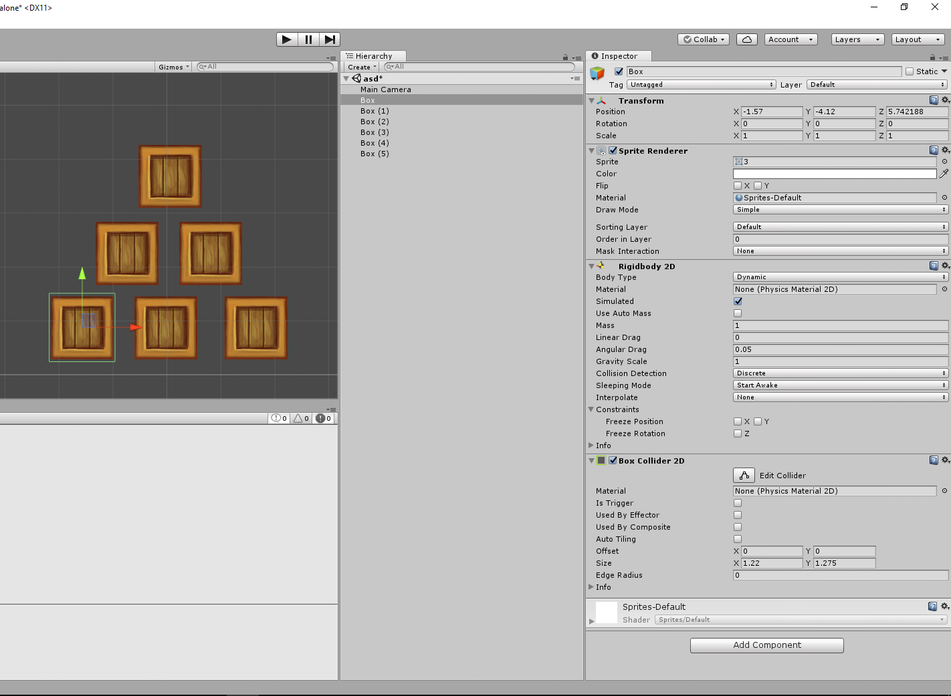

Step 2:
Make a simple BoxCollider2D at the bottom of the screen so that objects don’t fall down.
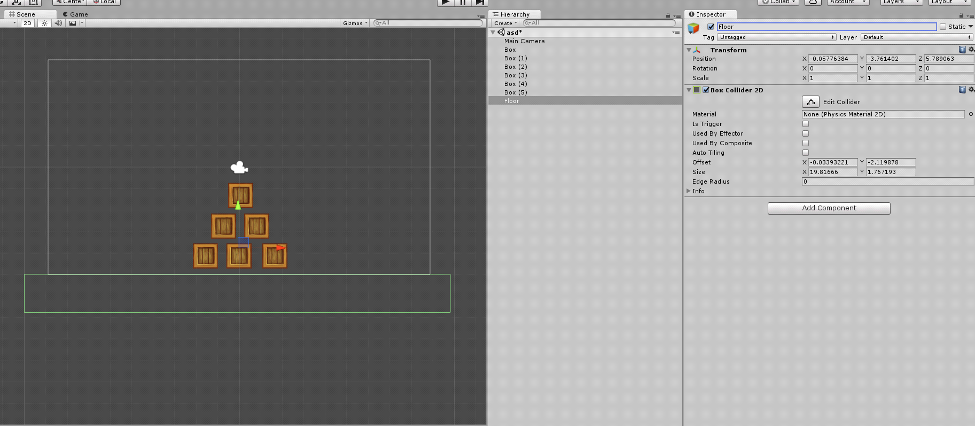

Step 3:
Create an empty Gameobject, and add the explosion component to that object.
For example: Add Component/Physics 2D Toolkit/ Single Explosion

Step 4:
Check the toolbox On Click. That means the explosion will be activated by the left mouse click.
You can also make reference to a SingleExplosion script form another script
and call a method named: Activate();

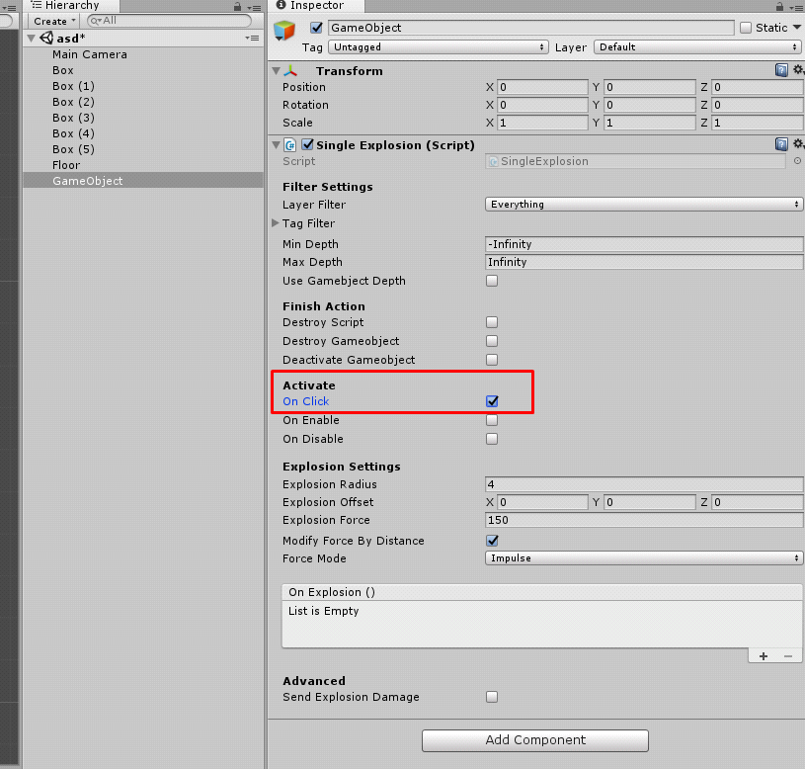

Step 5:
Finally, start the game and press the left mouse click.
This is it. Enjoy! :)

Explosions
Single Explosion
Add Component/Physics 2D Toolkit/Single Explosion
This is a simple explosion that applies force to a rigidbody that simulates explosion effect.

Uplift Explosion
Add Component/Physics 2D Toolkit/Uplift Explosion
This is the same as simple explosion, but it contains one additional feature - 'Uplift Modifier'. Using this parameter, you can easily make the explosion appear to throw objects up, which often gives a more dramatic effect than a simple outward force.

Double Explosion
Add Component/Physics 2D Toolkit/Double Explosion
These are the two simple explosions. The first explosion is activated instantly, and the second explosion can be activated with delay by modifying the 'Second Explosion Delay' parameter.

Triple Explosion
Add Component/Physics 2D Toolkit/Triple Explosion
These are the three simple explosions. The first explosion is activated instantly, then the second explosion can be activated with delay by modifying the 'Second Explosion Delay' parameter, and the third explosion is delayed with the 'Third Explosion Delay' parameter. NOTE! The 'Third Explosion Delay' parameter starts counting when the first explosion is activated (not the second)! - which means that the third explosion can be activated before the second!

Attractive Explosion
Add Component/Physics 2D Toolkit/Attractive Explosion
In order to achieve the effect of attractiveness, this is the best solution for you.
This explosion has two states:
1. Attraction: when activated, it will constantly attract rigidbodies towards the center of attraction. This attraction is used inside FixedUpdate().
2. Explosion: when the 'Explosion Delay' timer runs out, the attraction will stop, and the explosion will occur.

Unstable Explosion
Add Component/Physics 2D Toolkit/Unstable Explosion
This explosion has two states:
1. Shaking: when activated, based on the frequency settings, this will shake rigidbodies randomly.
2. Explosion: when the 'Explosion Delay' timer runs out, the shaking will stop, and the explosion will occur.

Pulsing Explosion
Add Component/Physics 2D Toolkit/Pulsing Explosion
This is a simple explosion that applies force to a rigidbody that simulates explosion effect. It can be useful for objects that constantly fall into the specific area, and need to be pushed away.

Settings
Filter Settings
Layer Filter : Chose layers that will be affected by the explosion.
Tag Filter : Chose tags that will be affected by the explosion.
Min Depth : Only include objects with a Z coordinate (depth), greater then or equal to this value.
Max Depth : Only include objects with a Z coordinate (depth), less then or equal to this value.
Use Gameobject Depth : Only include objects with a Z coordinate(depth) that are equal to this object Z coordinate(depth).
Use Trigger Colliders: Use trigger type of Collider2D.
Use Solid Colliders: Use solid type of Collider2D.
Finish Actions
Destroy Script : When the explosion is finished. Should this script automaticaly destroy itself?
Destroy Gameobject : When the explosion is finished. Should this Gameobject automaticaly destroy itself?
Deactivate Gameobject : When the explosion is finished. Should this Gameobject automaticaly deactivate itself?
Activate
On Click : Activate the explosion by the left mouse click ? This is useful for testing. But note that this works only in Editor!
On Enable : Activate the explosion when this Gameobject becomes enabled?
On Disable : Activate the explosion when this Gameobject becomes disabled?
Explosion Settings
Explosion Radius : Radius of the circle within witch the explosion has its effect.
Explosion Offset : The offset of the explosion position (World Space).
Explosion Force : The force of the explosion.
Modifie Force By Distance : if set to true, Force will be modified by distance, but Note that bodies with the center of mass outside the radius will not be affected by the explosion.
ForceMode2D : Use this to apply a certain type of force to a 2D RigidBody. There are two types of forces to apply: Force mode and Impulse Mode.

Methods
namespace: using ExplosionForce2D;
Rigidbody2D.AddExplosionForce2D
Public static void AddExplosionForce2D (float force, vector3 explosionPosition, float radius, bool modifyForceByDistance = true, bool lookAtMovingDirection = false, float lookAtAngleModifier = 0f, ForceMode2D = ForceMode2D.Force )
Public static void AddExplosionForce2D (float force, vector3 explosionPosition, float radius, bool modifyForceByDistance = true, ForceMode2D = ForceMode2D.Force )
Public static void AddExplosionForce2D (float force, vector3 explosionPosition, ForceMode2D = ForceMode2D.Force )
Parameters
force The force of the explosion.
explosionPosition The center of the circle witch the explosion has it's effect.
radius Radius of the circle within witch the explosion has it's effect.
modifyForceByDistance Force will be modified by distance.
lookAtMovingDirection Instantly rotate Rigidbody2D towards it's moving direction.
lookAtAngleModifier Modifies the angle of rotation
ForceMode2D The method used to apply the force to it's target.
Description
Applied a force to a Rigidbody2D that simulates explosion effects.
The explosion is modelled as a circle with a certian center position and radius in world space.
modifyForceByDistance if set to true, Force will be modified by distance, but Note that bodies with the center of mass outside the radius will not be affected by the explosion.
lookAtMovingDirection if set to true, Rigidbody2D will be instantly rotated towards it's moving direction, not force direction! This is useful when using every frame. It is recommended to apply this feature to round objects.
lookAtAngleModifier Modify the angle of rotation based on your initial sprites rotation.
Force can be applied only to an active Rigidbody2D. If a GameObject is inactive, AddExplosionForce2D has no effect.
Example
using UnityEngine;
using ExplosionForce2D;
public class ExampleClass : MonoBehaviour {
public float force = 25f;
public float radius = 4f;
public bool modifyForceByDistance = true;
public Vector3 offset = default(Vector3);
public ForceMode2D forceMode = ForceMode2D.Impulse;
private Collider2D[] colliders = new Collider2D[]{};
void Explode () {
colliders = Physics2D.OverlapCircleAll (transform.position,radius);
foreach (Collider2D hit in colliders) {
Rigidbody2D Rb = hit.GetComponent<Rigidbody2D> ();
if (Rb)
Rb.AddExplosionForce2D (force, transform.position + offset, radius, modifyForceByDistance, forceMode);
}
}
void Start () {
Explode ();
}
}

Rigidbody2D.AddUpliftedExplosionForce2D
Public static void AddUpliftedExplosionForce2D (float force, vector3 explosionPosition, float radius, float upliftModifier, bool modifyForceByDistance = true, bool lookAtMovingDirection = false, float lookAtAngleModifier = 0f, ForceMode2D = ForceMode2D.Force )
Public static void AddUpliftedExplosionForce2D (float force, vector3 explosionPosition, float radius, float upliftModifier, bool modifyForceByDistance = true, ForceMode2D = ForceMode2D.Force )
Parameters
force The force of the explosion.
explosionPosition The center of the circle witch the explosion has it's effect.
radius Radius of the circle within witch the explosion has it's effect.
upliftModifier Adjustment to the apparent position of the explosion.
modifyForceByDistance Force will be modified by distance.
lookAtMovingDirection Instantly rotate Rigidbody2D towards it's moving direction.
lookAtAngleModifier Modifies the angle of rotation
ForceMode2D The method used to apply the force to it's target.
Description
Applied a force to a Rigidbody2D that simulates explosion effects.
The explosion is modelled as a circle with a certian center position and radius in world space.
upliftModifier : Using this parameter, you can easily make the explosion appear to throw objects up, which often gives a more dramatic effect than a simple outward force.
modifyForceByDistance if set to true, Force will be modified by distance, but Note that bodies with the center of mass outside the radius will not be affected by the explosion.
lookAtMovingDirection if set to true, Rigidbody2D will be instantly rotated towards it's moving direction, not force direction! This is useful when using every frame. It is recommended to apply this feature to round objects.
lookAtAngleModifier Modify the angle of rotation based on your initial sprites rotation.
Force can be applied only to an active Rigidbody2D. If a GameObject is inactive, AddUpliftedExplosionForce2D has no effect.
Example
using UnityEngine;
using ExplosionForce2D;
public class ExampleClass : MonoBehaviour {
public float force = 25f;
public float radius = 4f;
public float upliftModifier = 1f;
public bool modifyForceByDistance = true;
public Vector3 offset = default(Vector3);
public ForceMode2D forceMode = ForceMode2D.Impulse;
private Collider2D[] colliders = new Collider2D[]{};
void Explode () {
colliders = Physics2D.OverlapCircleAll (transform.position,radius);
foreach (Collider2D hit in colliders) {
Rigidbody2D Rb = hit.GetComponent<Rigidbody2D> ();
if (Rb)
Rb.AddUpliftedExplosionForce2D (force, transform.position + offset, radius,upliftModifier, modifyForceByDistance, forceMode);
}
}
void Start () {
Explode ();
}
}

Rigidbody2D.AddAttractionForce2D
Public static void AddAttractionExplosionForce2D (float force, vector3 attractionPosition, float radius, bool modifyForceByDistance = true, bool lookAtMovingDirection = false, float lookAtAngleModifier = 0f, ForceMode2D = ForceMode2D.Force )
Public static void AddAttractionExplosionForce2D (float force, vector3 attractionPosition, float radius, bool modifyForceByDistance = true, ForceMode2D = ForceMode2D.Force )
Public static void AddAttractionExplosionForce2D (float force, vector3 attractionPosition, ForceMode2D = ForceMode2D.Force )
Parameters
force The force of the explosion.
attractionPosition The center of the circle witch the attraction has it's effect.
radius Radius of the circle within witch the attraction has it's effect.
modifyForceByDistance Force will be modified by distance.
lookAtMovingDirection Instantly rotate Rigidbody2D towards it's moving direction.
lookAtAngleModifier Modifies the angle of rotation
ForceMode2D The method used to apply the attraction force to it's target.
Description
Applied a attraction force to a Rigidbody2D that simulates explosion effects.
In order to achieve the effect of attractiveness, this is the best solution for you.
The attraction is modeled as a circle with a certain center position and radius in world space.
This Attraction Force should be used inside FixedUpdate().
modifyForceByDistance if set to true, Force will be modified by distance, but Note that bodies with the center of mass outside the radius will not be affected by the explosion.
lookAtMovingDirection if set to true, Rigidbody2D will be instantly rotated towards it's moving direction, not force direction! This is useful when using every frame. It is recommended to apply this feature to round objects.
lookAtAngleModifier Modify the angle of rotation based on your initial sprites rotation.
Attraction force can be applied only to an active Rigidbody2D. If a GameObject is inactive, AddAttractionForce2D has no effect.
Example
using UnityEngine;
using ExplosionForce2D;
public class ExampleClass : MonoBehaviour {
public float force = 25f;
public float radius = 4f;
public bool modifyForceByDistance = true;
public Vector3 offset = default(Vector3);
public ForceMode2D forceMode = ForceMode2D.Impulse;
private Collider2D[] colliders = new Collider2D[]{};
void Attraction () {
colliders = Physics2D.OverlapCircleAll (transform.position,radius);
foreach (Collider2D hit in colliders) {
Rigidbody2D Rb = hit.GetComponent<Rigidbody2D> ();
if (Rb)
Rb.AddAttractionForce2D (force, transform.position + offset, radius, modifyForceByDistance, forceMode);
}
}
void FixedUpdate () {
Attraction ();
}
}

Rigidbody2D.AddRandomizedExplosionForce2D
Public static void AddRandomizedExplosionForce2D (float force, vector3 explosionPosition, float radius, bool modifyForceByDistance = true, bool randomizeDirection = true, bool randomizeForce = false, ForceMode2D = ForceMode2D.Force )
Public static void AddRandomizedExplosionForce2D (float force, vector3 explosionPosition, bool randomizeDirection = true, bool randomizeForce = false, ForceMode2D = ForceMode2D.Force )
Parameters
force The force of the explosion.
explosionPosition The center of the circle witch the attraction has it's effect.
radius Radius of the circle within witch the attraction has it's effect.
modifyForceByDistance Force will be modified by distance.
randomizeDirection multiply force direction randomly with 1 or -1.
randomizeForce Multiply force with random value between 0 and 1.
ForceMode2D The method used to apply the attraction force to it's target.
Description
Applied a random force to a Rigidbody2D that simulates explosion effects.
The explosion is modeled as a circle with a certain center position and radius in world space.
randomizeDirection if set to true, the direction of the force will be multiplied with random sign (-1 or 1).
randomizeForce if set to true, Force will be multiplied with random value between 0 and 1.
modifyForceByDistance if set to true, Force will be modified by distance, but Note that bodies with the center of mass outside the radius will not be affected by the explosion.
explosion force can be applied only to an active Rigidbody2D. If a GameObject is inactive, AddAttractionForce2D has no effect.
Example
using UnityEngine;
using ExplosionForce2D;
public class ExampleClass : MonoBehaviour {
public float force = 25f;
public float radius = 4f;
public bool modifyForceByDistance = true;
public Vector3 offset = default(Vector3);
public ForceMode2D forceMode = ForceMode2D.Impulse;
private Collider2D[] colliders = new Collider2D[]{};
void Explosion () {
colliders = Physics2D.OverlapCircleAll (transform.position,radius);
foreach (Collider2D hit in colliders) {
Rigidbody2D Rb = hit.GetComponent<Rigidbody2D> ();
if (Rb)
Rb.AddRandomizedExplosionForce2D (force, transform.position + offset, radius, modifyForceByDistance,true,true, forceMode);
}
}
void Start () {
Explosion ();
}
}
Send Explosion Damage
You can send custom explosion damage. This feature uses the Unity 'SendMessage()' method.
See: https://docs.unity3d.com/ScriptReference/GameObject.SendMessage.html
Explosion Damage: is the custom damage and has nothing to do with explosion force. You can specify this, for example, based on enemy type.
Modify Damage By Distance: if set to true, 'Explosion Damage' will be modified based on the distance between rigidbodies and the explosion center.
Method To Call: is the name of the method to call on a targeted Gameobject that holds the Rigidbody2D component affected with explosion.
Options : 'Require Reciver' or 'Dont Require Reciver' . Should an error be raised if the method doesn't exist on the target Gameobject?
Example
using UnityEngine;
public class Enemy : MonoBehaviour {
public float health = 100f;
public void TakeExplosionDamage (float damage) {
health -= damage;
}
}
Description
When an enemy, that has Rigidbody2D and this class attached, is affected by the explosion, the ‘TakeExplosionDamage’ method will be called, and the ‘Explosion Damage’ that we specified will be passed as ‘damage’ parameter. Let's say our enemy has 100 healths, and we setup the explosion like this:
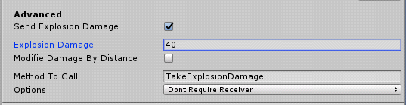
So after the explosion occure the enemy will have 60 healths left.
Radius Color
You can change the color of the explosion radius by opening the script 'ExplosionForce2DPreferences' which is located in: Assets/ExplosionForce2D/Scripts/Main
Physics2D.OverlapCircleNonAlloc
By default, all explosions use Physics2D.OverlapCircleAll, and if you want to use Physics2D.OverlapCircleNonAlloc, there is a comment example in every explosion at the bottom of the script, under the #region OverlapCircleNonAlloc.
The disadvantage of using OverlapCircleNonAlloc is that the explosion is limited to a certain number of rigidbodies that can be affected. Basically, you must specify the max number of rigidbodies.
The advantage of using OverlapCircleNonAlloc is that no memory is allocated for the result, so garbage collection performance is improved when the check is performed frequently.
See : https://docs.unity3d.com/ScriptReference/Physics2D.OverlapCircleNonAlloc.html

